Programming Assignment 1

In this assignment, you’ll write the Java code for an app that converts temperature from degrees Fahrenheit to degrees Celsius. When you’re done, the app should look like this:

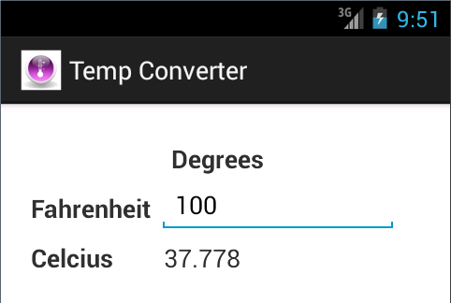

**Open the app and test it**

1. Start Android Studio and open the project named ch03_ex4_TempConverter (PA1 Starter Code).
2. Run this project and test the app with a valid subtotal like 100. The app should accept this input, but it shouldn’t perform any calculations or display any results.

**Write the Java code**

1. Open the Java class for the only activity of this app.
2. Use the onCreate method to get references to the EditText widget and the TextView widget that displays the degrees in Celsius.
3. Create an event handler for the EditorAction event for the EditText widget. The event handler should calculate and display the degrees in Celsius when the Done key is pressed on the soft keyboard. The formula for converting temperatures from Fahrenheit to Celsius is:

**c = (f-32) * 5/9**

1. Test the app. At this point, it should make the calculation correctly. However, it will lose its data if you change orientation or navigate away from the app.
2. Override the onPause method so it saves a string for the degrees Fahrenheit and Celsius. Then, modify the onResume method so it gets these strings and sets them on the appropriate widgets.
3. Test the app again. This time, the app should always remember its data even if you change orientation or navigate away from the app and return to it.